**Synopsis**

|  |  |
| --- | --- |
| **CONVERSION OF SIGN LANGUAGE INTO AUDIO AND TEXT FORM** | |
|  | |
| **Student’s Name** | **USN** |
| B SHAMANTH KOWSHIK | 1JB17EC081 |
| UDAY K V | 1JB17EC096 |
|  | |
| **Contents**   * **Introduction** * **Literature survey** * **Challenges and Motivation.** * **Objectives (With Block Diagram, If any).** * **Methodology** * **Possible outcomes.** * **References (Bibliography)** | |
|  | |

**INTRODUCTION**

* The inability of normal people(who don’t understand sign language) to comprehend sign language gestures results in a communication barrier between normal and hearing and speech impaired people.
* The project aims to bridge the communication gap by developing an effective gadget that converts sign-language gestures into audio and textual form providing quick information exchange.
* Sign language is a means of communication for the acoustically disabled individuals , which involves simultaneous use of facial expressions , orientation and movement of hand , finger spellings , body language , head movement and eye gazes in order to effectively convey the message and thought of a person.
* Even with usage of sign language , hearing and speech impaired people would face a lot of difficulties in communicating their thoughts and ideas , especially to those who have meager or no knowledge of sign language.

**LITERATURE SURVEY**

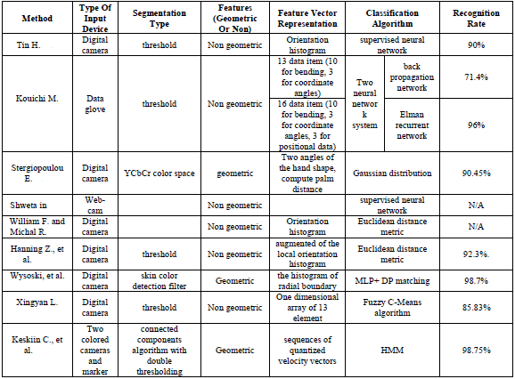

**CHALLENGES AND MOTIVATION**

* Long conversations are extremely difficult for disabled people as it takes a lot of time and effort.
* People who use the sign language have to be in close proximity to other people to convey their messages.
* Sometimes they have to break up activities, such as communicate then eat or write and then communicate, which is extremely weary.
* They can only communicate with ASL with two people at the same time, more than that then they require interpreters.( ASL- American Sign Language).
* ASL involves a lot of physical contact, which isn’t much comfortable for most people.
* Our project aims at solving all the above problems, which is a great motivation to carry it forward.

**OBJECTIVES**

The project aims to develop mobile interactive application software for translation of American Sign Language to speech and text and vice versa, to assist communication between hearing and speech impaired people with normal people. The language translator should be able to translate 26 alphabet gestures from the American Sign Language into speech and text and vice versa.

**BLOCK DIAGRAM**

**LCD display screen**

**FPGA**

**Web camera**

Sign Language



**Speaker**

**METHODOLOGY**

The methodologies implemented in this project involve ASL, computer or laptop, data glove, MATLAB, Gesture recognition, image processing, Edge detection, Grey scale image.

**POSSIBLE OUTCOME**

This project is a small step towards helping a physically challenged people and lot more can be done to make the product more sophisticated, user friendly & efficient. Using more memory and powerful microprocessor, more languages can be covered. This project can be modified to make it compatible with mobile phones. We can increase the range of product by using more powerful trans-receiver module.

**REFERENCES**

[1] Wikipedia. Sign Language, 2012. http://en.wikipedia.org/wiki/Sign_language, accessed Feb. 2012.

[2] P. Boyes Braem. *Einführung in die Gebärdensprache und ihre Erforschung (Introduction to sign language and its study)*. Signum, Hamburg, Ger., 1995.

[3] S. Prillwitz, R. Leven, H. Zienert, T. Hanke, and J. Henning. *Hamburg Notation System for Sign Languages – An Introductory Guide*. Institute of German Sign Language andCommunication of the Deaf, University of Hamburg, Hamburg, Ger., 1989.

[4]Wikipedia.File:Aslfingerspellalpha,2011. http://en.wikipedia.org/wiki/File:Aslfingerspellalpha.png, accessed Apr. 2012.

[5]Wikipedia,AmericanSignLanguage,2012. http://en.wikipedia.org/wiki/American_Sign_Language, accessed Jan. 2012.

[6] B. Vicars. Basic Signs Pictures, n.d. http://www.lifeprint.com/asl101/pages-layout/concepts.htm, accessed Dec. 2011.

[7] Wikipedia. IMAGE PROCESSING, <http://en.wikipedia.org/wiki/Image_processing>

[8] Wikipedia. RGB COLOR MODEL, http://en.wikipedia.org/wiki/Color_model

[9] Wikipedia. CAMERA, <http://en.wikipedia.org/wiki/Camera>

[10] Noor Adnan Ibraheem Department of Computer Science A.M.U., Aligarh Uttar Pradesh, India. *Survey on Various Gesture Recognition Technologies and Techniques.* Volume 50 – No.7, July 2012

**Acceptance by the Guide(s) :**

This project is accepted and will be carried out under my supervision.

May be filled after guide allotment

________________ ____(if applicable else delete)____

Name & Signature Name & Signature

Internal Guide External Guide